**How to use sweet alert in livewire**

1.

[Laravel Livewire Sweetalert Example - ItSolutionStuff.com](https://www.itsolutionstuff.com/post/laravel-livewire-sweetalert-exampleexample.html)

2.

[How to use Sweet Alert in Laravel Livewire - Bing video](https://www.bing.com/videos/search?q=how+to+use+sweetalert+in+livewire+laravel&docid=607998491421972872&mid=8569D0A8B536DF4CE1C78569D0A8B536DF4CE1C7&view=detail&FORM=VIRE)

3. www . https:// sweetalert2.github.io

From this site take sweetalert script/code

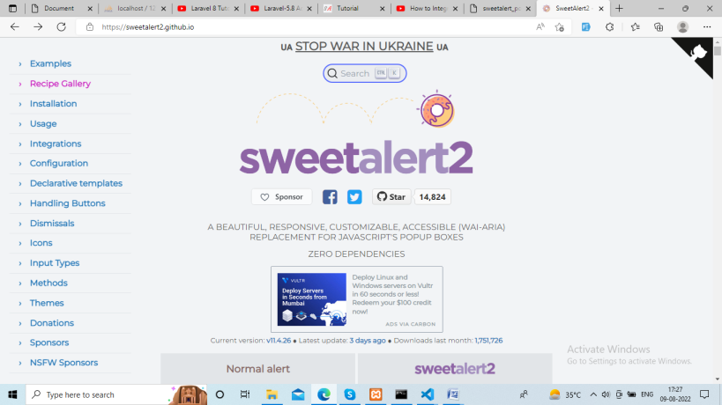

1.

**Install Sweet Alert Package**

composer require realrashid/sweet-alert

2.

php artisan sweetalert:publish

3.

### Setup Blade View

@include('sweetalert::alert')

**resources/views/layouts/app.blade.php**

<!DOCTYPE html>

**<html>**

**<head>**

**<title>**Laravel Livewire Example - ItSolutionStuff.com**</title>**

@livewireStyles

**<script** **src**="//cdnjs.cloudflare.com/ajax/libs/jquery/3.2.1/jquery.min.js"**></script>**

**<link** **href**="//maxcdn.bootstrapcdn.com/bootstrap/4.1.1/css/bootstrap.min.css" **rel**="stylesheet" **id**="bootstrap-css"**>**

**<script** **src**="//maxcdn.bootstrapcdn.com/bootstrap/4.1.1/js/bootstrap.min.js"**></script>**

**<script** **src**="https://unpkg.com/sweetalert/dist/sweetalert.min.js"**></script>**

**</head>**

**<body>**

**<div** **class**="container"**>**

@yield('content')

**</div>**

**</body>**

@livewireScripts

**<script>**

window.addEventListener('swal:modal', event => {

swal({

title: event.detail.message,

text: event.detail.text,

icon: event.detail.type,

});

});

window.addEventListener('swal:confirm', event => {

swal({

title: event.detail.message,

text: event.detail.text,

icon: event.detail.type,

buttons: **true**,

dangerMode: **true**,

})

.then((willDelete) => {

**if** (willDelete) {

window.livewire.emit('remove');

}

});

});

**</script>**

**</html>**

**app/Http/Livewire/NotificationSweetAlert.php**

<?php

**namespace** App\Http\Livewire;

**use** Livewire\Component;

**class** NotificationSweetAlert **extends** Component

{

**protected** $listeners = ['remove'];

/**

* Write code on Method

*

* @return response()

*/

**public** **function** render()

{

**return** view('livewire.notification-sweet-alert')->**extends**('layouts.app');

}

/**

* Write code on Method

*

* @return response()

*/

**public** **function** alertSuccess()

{

$this->dispatchBrowserEvent('swal:modal', [

'type' => 'success',

'message' => 'User Created Successfully!',

'text' => 'It will list on users table soon.'

]);

}

/**

* Write code on Method

*

* @return response()

*/

**public** **function** alertConfirm()

{

$this->dispatchBrowserEvent('swal:confirm', [

'type' => 'warning',

'message' => 'Are you sure?',

'text' => 'If deleted, you will not be able to recover this imaginary file!'

]);

}

/**

* Write code on Method

*

* @return response()

*/

**public** **function** remove()

{

/* Write Delete Logic */

$this->dispatchBrowserEvent('swal:modal', [

'type' => 'success',

'message' => 'User Delete Successfully!',

'text' => 'It will not list on users table soon.'

]);

}

}

Sweetalert in laravel

-----------sweetalert confirm in laravel using ajax-------------

<button class="btn btn-danger servideletebtn"

data-id="{{ $favourite->id }}">Delete</button>

<script src="https://cdnjs.cloudflare.com/ajax/libs/sweetalert/2.1.0/sweetalert.min.js"></script>

<script type="text/javascript">

$('.servideletebtn').click(function(event) {

var form = $(this).closest("form");

var name = $(this).data("name");

event.preventDefault();

swal({

title: `Are you sure you want to remove cleaner from Favourites?`,

text: "If you delete this, it will be gone forever.",

icon: "warning",

buttons: true,

buttons: ["No", "Yes"],

dangerMode: true,

})

.then((willDelete) => {

if (willDelete) {

form.submit();

}

});

});

</script>

public function deleteFavouriteCleaner($id)

{

if ($id) {

Favourite::find($id)->delete();

}

return back();

// return response()->json(['status' => 'Category Deleted Successfully']);

}